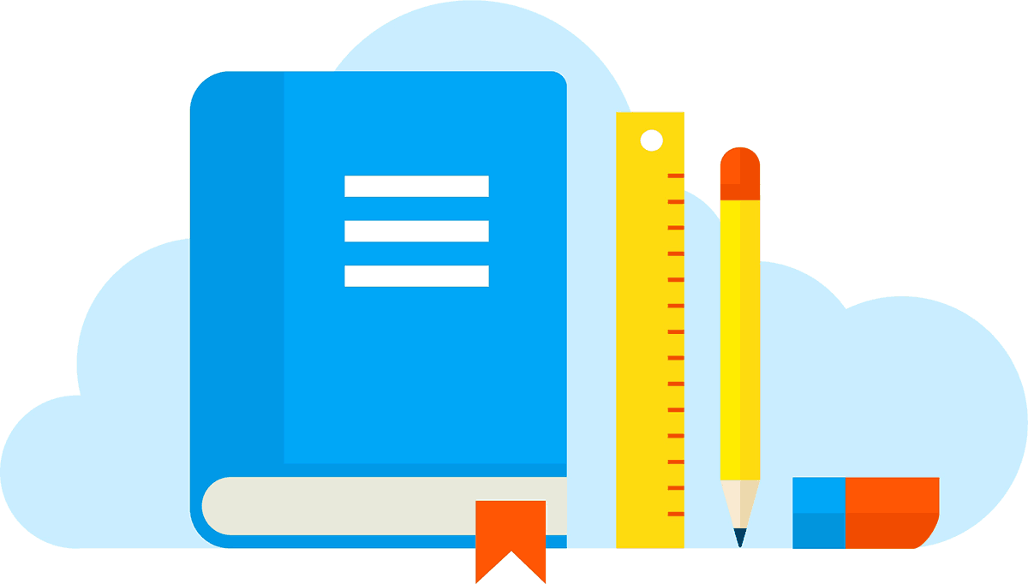

Teacher Resources for Multiple Content and Grade Levels

INFOhio - Added new resources for school closure: Click on the special banner at the top. Educator Tools with over 70,00 lesson plans in addition to webquests, instructional bags, videos, lessons with digital content including digital video collection, Storia e-book collections, etc.
https://www.infohio.org/

Learn Everywhere - Links and tools for teachers and families during school closure for all grade levels and 7 subjects with games, activities, and virtual field trips in a very user friendly format.
http://learneverywhere.org/

Khan Academy - Largest collection by grade and content area. Includes core subjects plus AP courses, engineering, computer programming, and more.
https://www.khanacademy.org/

Curriki - Curriculum and lesson plans for K-12 all in digital format in multiple content areas including core subjects, CTE, computer science, and the arts.
https://www.curriki.org/

Deck Toys - Build complete lessons within minutes with your existing teaching content such as study sets, PPT or Google Slides for fun and interactive game-based learning.
https://deck.toys/

Kahoot - Create your own kahoot in minutes or choose from 30+ million read-to-play games to assess learning.
https://kahoot.com/schools/distance-learning/

ScootPad - Meet students exactly where they are with the right level of practice, instruction, remediation and assessment to ensure they master every concept.
https://www.scootpad.com/

EPIC! Digital Library - Digital library of over 35,000 books.
https://www.getepic.com/

Edpuzzle - Interactive video lessons with student progress tracking.
https://support.edpuzzle.com/hc/en-us/articles/360039805612-Help-for-schools-affected-by-Covid-19

CommonLit - 2,000 high-quality free reading passages of texts for multiple content areas, levels, genres, book pairings, etc. for grades 3-12, complemented by aligned interim assessments.
https://www.commonlit.org/

Brain Pop - Educator-focused engaging learning games, animated movies, and activities for students of various levels, including K-3 and EL.
https://educators.brainpop.com/

Gamilab -Create fun and engaging learning games for your class, or give your students an opportunity to be part of the game creation process by having them come up with their own questions, quizzes and tests.
https://gamilab.com/school

FlipGrid - Social learning for Pre-K and up. Learners share ideas, stories, and work via short videos.
https://info.flipgrid.com/

Smithsonian Tween Tribune - Articles on a variety of topics for grades K-12 with multiple lexiles for one article.
https://www.tweentribune.com/

Newsela - Thousands of real-world texts that feature diverse perspectives and people all students can identify with.
https://newsela.com/

Gynzy - Educational software that combines standards-aligned lessons, bite-sized games & activities, and class management tools to unlock the potential of your Interactive Whiteboard.
https://www.gynzy.com/en/

HippoCampus - 7,000 videos in 13 subject areas
https://hippocampus.org/

PBS Learning Media - Standards-aligned videos, interactives, lesson plans, and more for P-K - High School.
https://westernreserve.pbslearningmedia.org/

